**Name of the experiment**:

Setting up a star topology network using “Cisco Packet Tracer” Software and getting familiar with the basic CLI (Command Line Interface) commands.

**Theory:**

A star topology is a topology for a Local Area Network (LAN) in which all nodes are individually connected to a central connection point, like a hub or a switch. In the “Cisco Packet Tracer” software, any network with different types of networking components and end devices can be simulated and network can be established. For this experiment, as a star topology will be implemented in the Cisco Packet Tracer, a central device known as Switch and four end devices (here using PC) were used in the software editor section. A network switch (also called switching hub, bridging hub, officially MAC bridge) is networking hardware that connects devices on a computer network by using packet switching to receive and forward data to the destination device. After that, four connecting wires (here using copper straight through) were used for connecting four end devices with the switch. After implementing all those components in the editor, a topology can be formed like below :

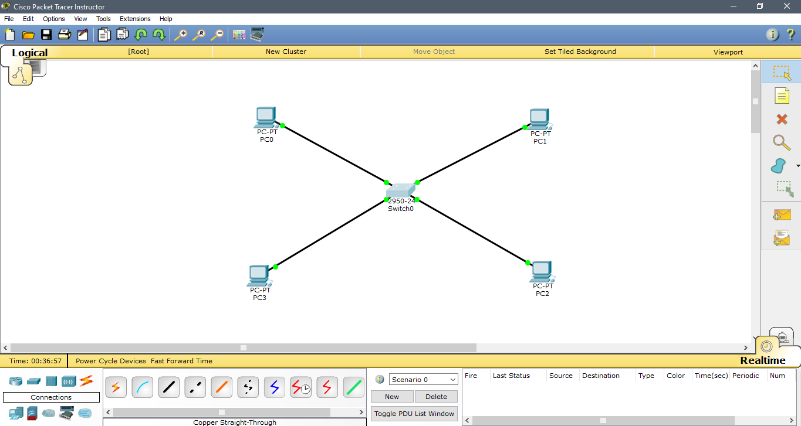

**Commands for CLI (Command Line Interface) :**

**Switch>**

* This is User EXEC mode.

**Switch> enable**

* for switching to Privileged EXEC mode from User EXEC mode.

**Switch#**

* This is Privilged EXEC mode.

**Switch>disable**

* for switching to User EXEC mode from Privileged EXEC mode.

**Switch# config terminal**

* for configuring the switch.

**Switch# line console 0**

* for configuring the console.

**Switch# interface vlan 1**

* for configuring the switch interface of vlan1.

**Switch# config terminal**

**Switch(config)# hostname switch0**

* for changing the switch’s hostname.

**switch0 # config terminal**

**switch0 (config)# interface vlan 1**

**switch0 (config-if)# ip address 192.168.10.2 255.255.255.0**

**switch0 (config-if)# no shutdown**

* Adding an ip address and subnetting to a network.

**switch0 # show running-config**

* Shows the running configuration of the network.

**switch0 # config terminal**

**switch0 (config)# line console 0**

**switch0 (config-line)# password akash**

**switch0 (config-line)# login**

* For setting up password to running network.

**switch0(config-if)# exit**

**switch0(config)# exit**

**switch0#**

* For exiting one step back.

**switch0(config-if)# end**

**switch0# end**

* For going all the way back to start.

**Discussion:**

From the above experiment, the simulation of a star topology network having a switch and three end devices has been established and using some basic commands of CLI, many operations can be performed in our network, such as adding IP address with subnet mask, adding password and interfacing and line configuring along with configuring the terminal. Also there are two EXEC mode called User EXEC mode and Privileged EXEC mode that can be accessible by commanding disable and enable respectively.